Machine Learning 1
Lily Kendall
Due 2/18/26
Assignment 2

Question 1 (20 points)

Let us explore how to perform an RFM analysis by dividing customers into quintiles. For each customer, you'll look at Recency, the maximum number of days since 2024-12-31, along with the median number of items purchased (Frequency), and the total transaction amounts (Monetary). Even if some transactions show zero or negative item counts or quantities, don't worry — you'll include all of them in your analysis to get a complete picture.

- (10 points) What are the quintiles for Recency, Frequency, and Monetary values?

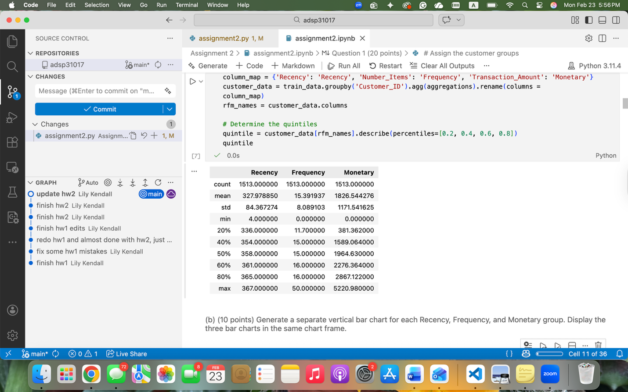

- (10 points) Generate a separate vertical bar chart for each Recency, Frequency, and Monetary group. Display the three bar charts in the same chart frame.

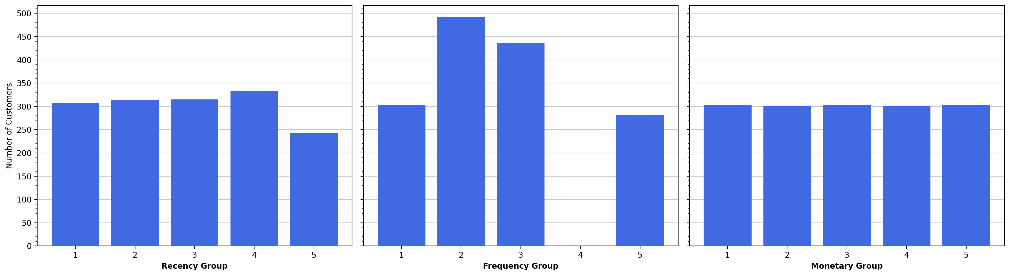

Question 2 (20 points)

Once you've rescaled the Recency, Frequency, and Monetary values to a range of 0 to 100, you'll perform k-means clustering on these rescaled numbers.

- (10 points) Try the number of clusters between 2 and 15, inclusive, then plot the Elbow values, the Silhouette Scores, the Calinski and Harabasz Scores, and the Davies-Bouldin Scores versus the number of clusters. Your initial random seed is 710136264; add 31 after each trial.

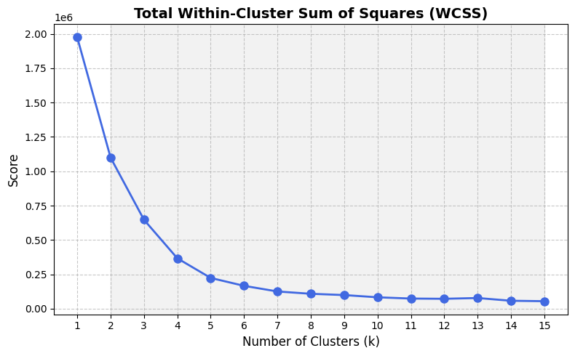

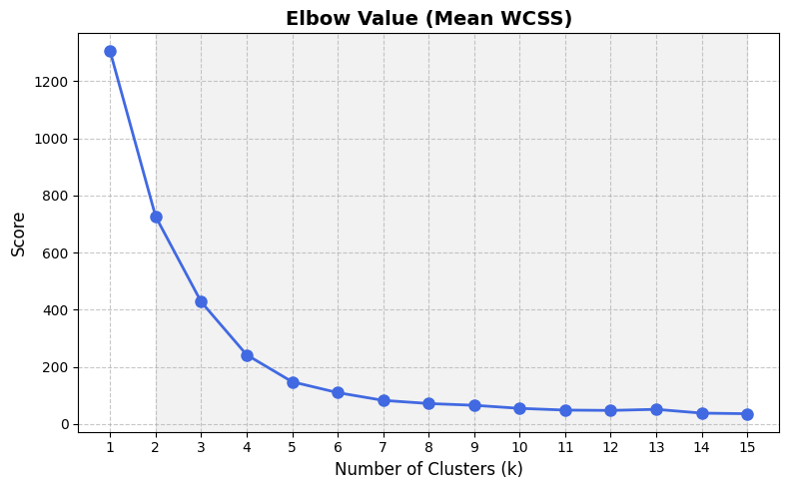

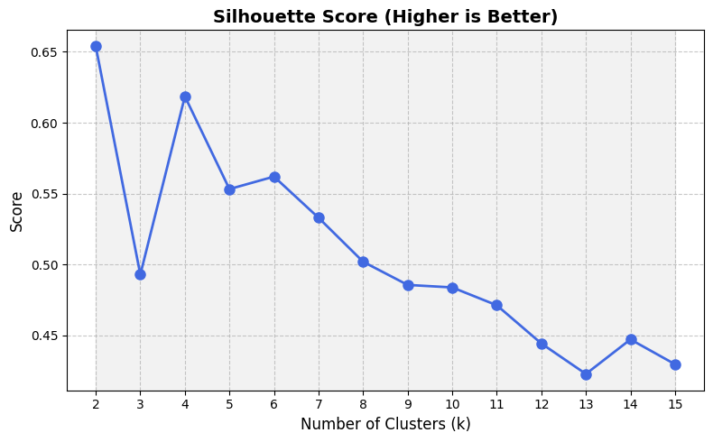

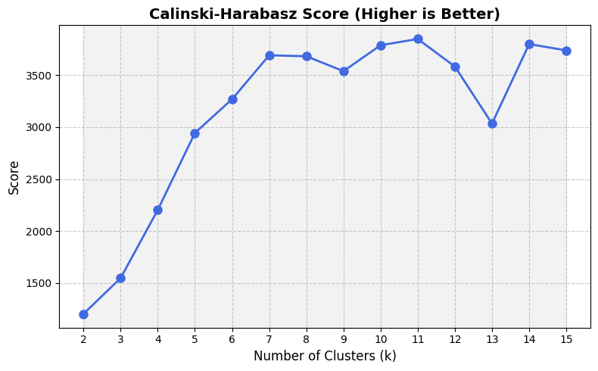

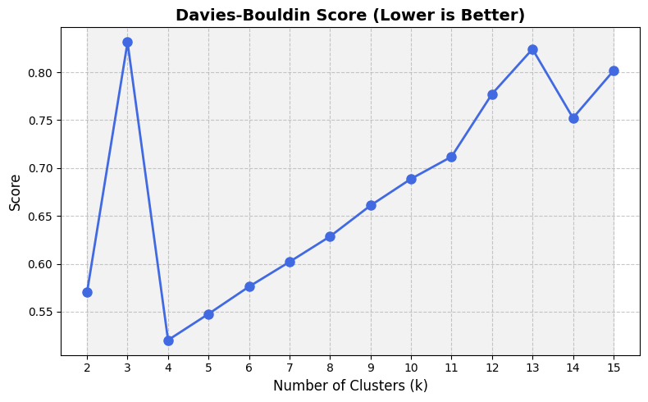

- (10 points) What will you suggest for the number of clusters based on the four metrics?

I would suggest 4 clusters because it has the highest silhouette score (besides 2) and appears to be the “elbow point” on the elbow plot, where the score begins to plateau. Although 2 clusters have a higher silhouette score, 4 clusters have a much higher Calinski-Harabasz score, and show a much clearer “elbow”.

Question 3 (20 points)

Use the t-Distributed Stochastic Neighbor Embedding (t-SNE) method to project the scaled Recency, Frequency, and Monetary values into a two-dimensional space. You will try perplexity values between 5 and 50 in increments of 5. Your initial random seed is 710136202; add 31 after each trial.

- (10 points) Generate a scatterplot of the embeddings for each perplexity value. Display the ten scatterplots in the same chart frame.

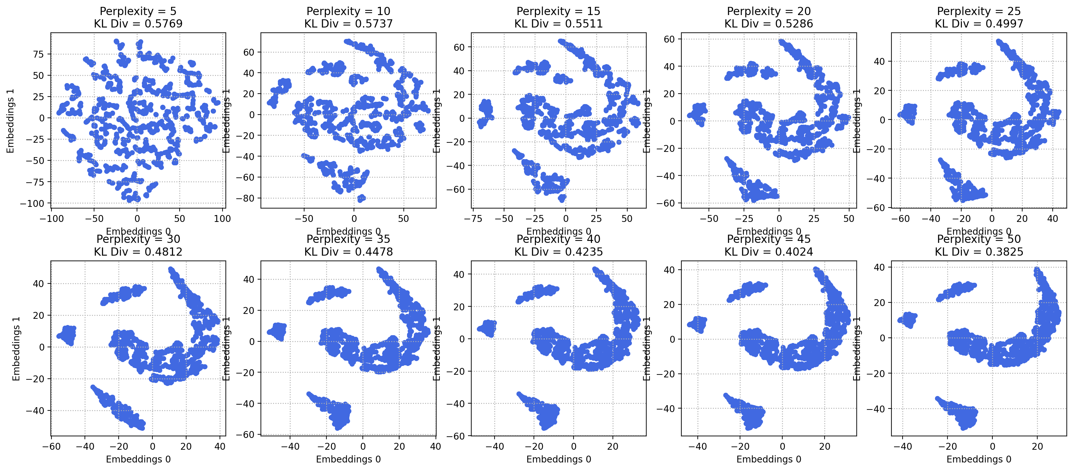

- (10 points) How many clusters will you identify based on the above scatterplots?

There appear to be 4 distinct clusters: an arched cluster and three smaller clusters toward the left.

Question 4 (20 points)

After choosing the perplexity value that results in the smallest Kullback–Leibler divergence, you'll find meaningful clusters within the t-SNE embeddings.

- (10 points) Try the number of clusters between 2 and 15 inclusively, then plot the Elbow values, the Silhouette Scores, the Calinski and Harabasz Scores, and the Davies-Bouldin Scores versus the number of clusters. Your initial random seed is 710136264; add 31 after each trial.

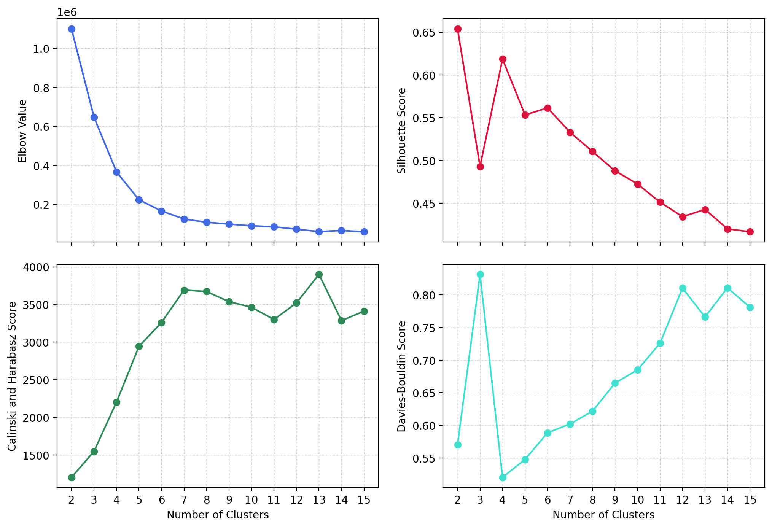

- (10 points) What will you suggest for the number of clusters based on the four metrics?

Again, I would suggest 4 clusters due to the highest silhouette score and the lowest Davies-Bouldin score. There appears to be an “elbow” at 4 clusters additionally. Although the Calinski-Harabasz score is lower than for clusters greater than 4, the high silhouette score and low Davies-Bouldin score prove a greater case.

Question 5 (20 points)

Since our goal in this experiment is to see if we can simplify the 125 segments from the RFM analysis into a few groups without losing their unique qualities, you'll cross-tabulate the cluster memberships from Question 4 with each Recency, Frequency, and Monetary group.

- (10 points) Show the three cross-tabulation tables. We prefer to place the cluster memberships on the rows and the RFM variables on the columns. The cell contents are row percentages (i.e., the percentages within a row should sum to 100%).
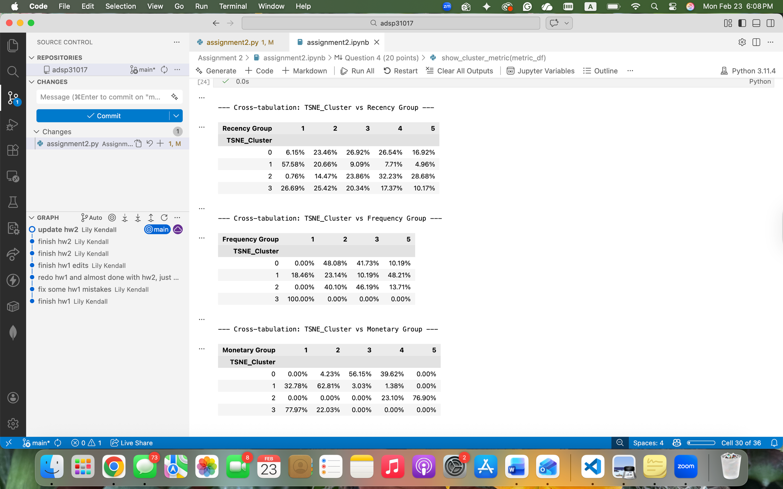

- (10 points) What findings can you draw from these cross-tabulation tables?

The findings from the cross-tabulation tables reveal that the t-SNE clustering method did indeed simplify the 125 potential RFM combinations into 4 distinct segments. Cluster 2 captures almost all of the customers in the highest monetary group, and a majority of the customers in the highest two recency groups, indicating that cluster 2 is the “loyal VIP” segment. On the other hand, cluster 3 captures the entire bottom frequency group and almost the entire bottom monetary group, making this cluster the “occasional purchaser” group. Cluster 0 captures the average customer with a wider spread of values, mostly in the middle groups. Finally, cluster 1 has a majority of customers in the lower recency and monetary groups, but around half of the customers are in the higher frequency group, capturing the customers who do not make as many purchases anymore.

